WT Assignment 6
Neeti Kurulkar
Web App using JSP

Database and Table creation in MySQL

CREATE DATABASE studentdb;
USE studentdb;

CREATE TABLE student_info (
stud_id INT PRIMARY KEY AUTO_INCREMENT,
stud_name VARCHAR(100) NOT NULL,
class VARCHAR(10) NOT NULL,
division CHAR(1) NOT NULL,
city VARCHAR(50) NOT NULL
);

DESCRIBE student_info;

INSERT INTO student_info (stud_name, class, division, city)
VALUES
('Amit Sharma', '10', 'A', 'Mumbai'),
('Priya Verma', '12', 'B', 'Delhi'),
('Rahul Mehta', '11', 'C', 'Bangalore'),
('Sneha Kulkarni', '10', 'B', 'Pune'),
('Vikas Yadav', '12', 'A', 'Chennai');

SELECT * FROM student_info;

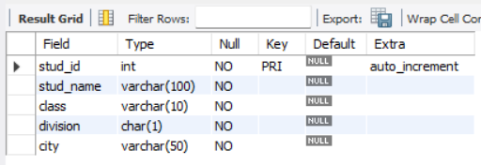

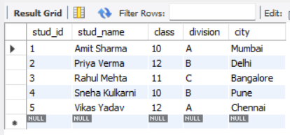

Dynamic Web Project in Eclipse

JSP Codes

- Index.jsp

<%@ page import="java.sql.*" %>
<%@ page contentType="text/html;charset=UTF-8" language="java" %>
<html>
<head>
<title>Student Information</title>
<link rel="stylesheet" href="css/bootstrap.css">
<style>
body {
font-family: Arial, sans-serif;
margin: 40px;
}
table {
width: 100%;
border-collapse: collapse;
margin-top: 20px;
}
th, td {
border: 1px solid #ddd;
padding: 12px;
text-align: left;
}
th {
background-color: #4CAF50;
color: white;
}
tr:hover {
background-color: #f5f5f5;
}
.container {
max-width: 900px;
margin: 0 auto;
}
h2 {
text-align: center;
}
</style>
</head>
<body>
<div class="container">
<h2>Student Information</h2>
<%
Connection conn = null;
PreparedStatement stmt = null;
ResultSet rs = null;
String url = "jdbc:mysql://localhost:3306/studentdb";
String user = "root";
String password = "root";

try {
Class.forName("com.mysql.cj.jdbc.Driver");
conn = DriverManager.getConnection(url, user, password);
String query = "SELECT * FROM student_info";
stmt = conn.prepareStatement(query);
rs = stmt.executeQuery();
%>
<table>
<thead>
<tr>
<th>Student ID</th>
<th>Student Name</th>
<th>Class</th>
<th>Division</th>
<th>City</th>
</tr>
</thead>
<tbody>
<%
while (rs.next()) {
%>
<tr>
<td><%= rs.getInt("stud_id") %></td>
<td><%= rs.getString("stud_name") %></td>
<td><%= rs.getString("class") %></td>
<td><%= rs.getString("division") %></td>
<td><%= rs.getString("city") %></td>
</tr>
<%
}
%>
</tbody>
</table>
<%
} catch (Exception e) {
e.printStackTrace();
%>
<p>Error: <%= e.getMessage() %></p>
<%
} finally {
if (rs != null) rs.close();
if (stmt != null) stmt.close();
if (conn != null) conn.close();
}
%>
</div>
</body>
</html>

- Web.xml

<?xml version="1.0" encoding="UTF-8"?>
<web-app version="4.0" xmlns="http://xmlns.jcp.org/xml/ns/javaee"
xmlns:xsi="http://www.w3.org/2001/XMLSchema-instance"
xsi:schemaLocation="http://xmlns.jcp.org/xml/ns/javaee
http://xmlns.jcp.org/xml/ns/javaee/web-app_4_0.xsd"
id="WebApp_ID">

<display-name>BookWebApp</display-name>

<welcome-file-list>
<welcome-file>home.html</welcome-file>
</welcome-file-list>

</web-app>

Output:
